**EVIDENCE OF PSC BANK PAYMENT FOR SNEPCo 2019 DISPOSALS**

Doc218734982- Disposal of scrap materials Backloaded from Bonga FPSO currently stored at Onne Warehouse Yard (Batch 6)

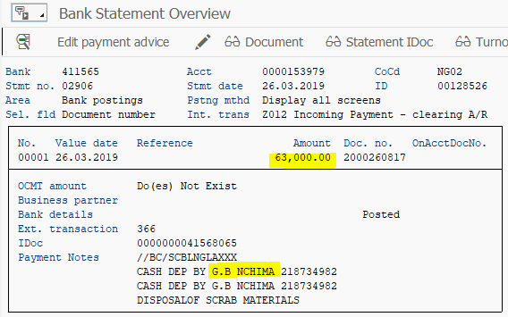

Doc 217814559- Disposal of Bonga Batch 5 Backload, H beams at Onne

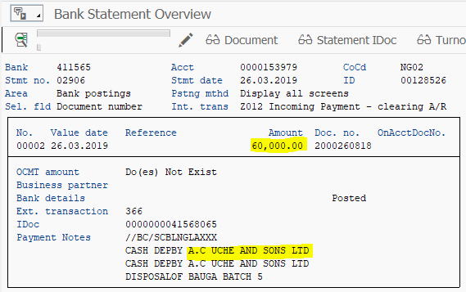

Doc- 213390035 Sales of EPRS Pipes at Onne

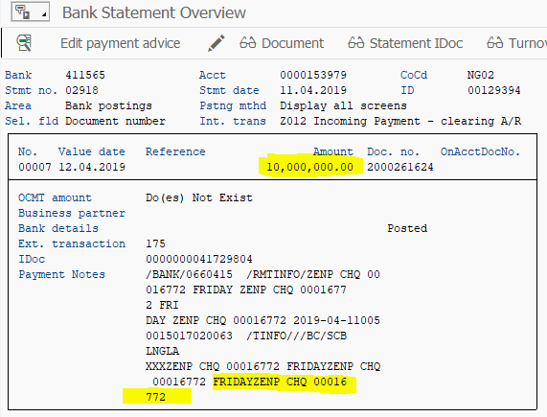

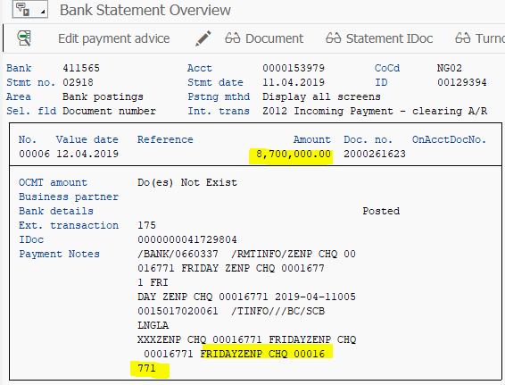

Doc-216743177-Disposal of Bonga materials (1 Lot H Beam) at Onne SNEPCo

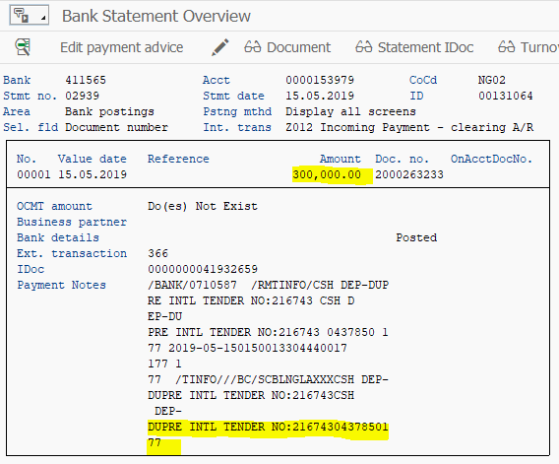

Doc 216413605_ Disposal of Bonga materials (9MW GT Alternator and H Beams at Onne SNEPCo

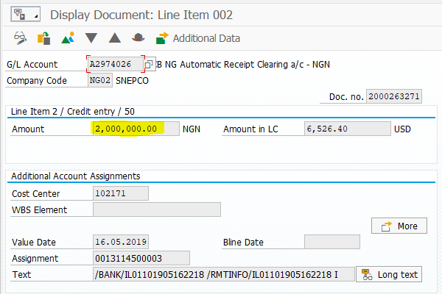

DOC 275547096_DISPOSAL OF BULKY MATERIALS AT ONNE

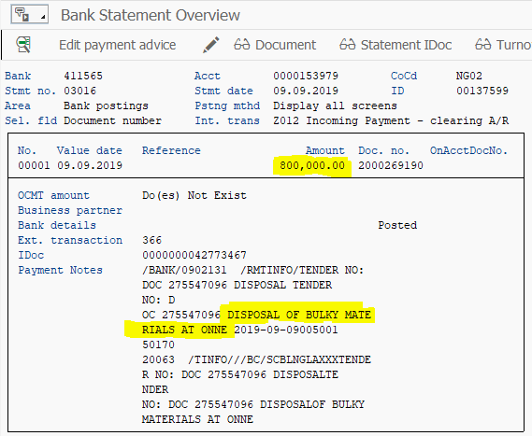

Doc 274653997_Disposal of NG28 surplus materials at Onne batches 3 and 4 NAPIMS Lot

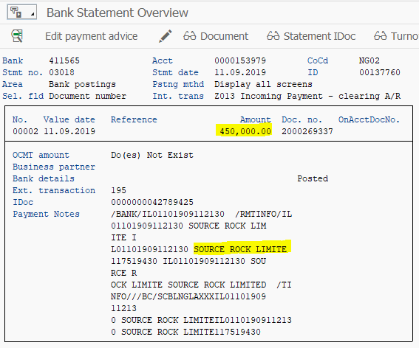

DOC 275956054_DISPOSAL OF NG28 SURPLUS MATERIALS AT ONNE BATCHES 1 AND 2 SNEPCo LOT

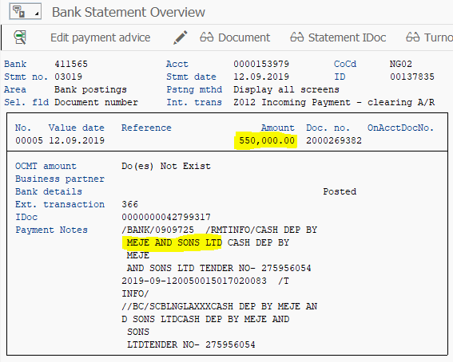

**DOC 274438758_DISPOSAL OF NG28 SURPLUS MATERIALS AT ONNE (BATCH 3 AND 4)**

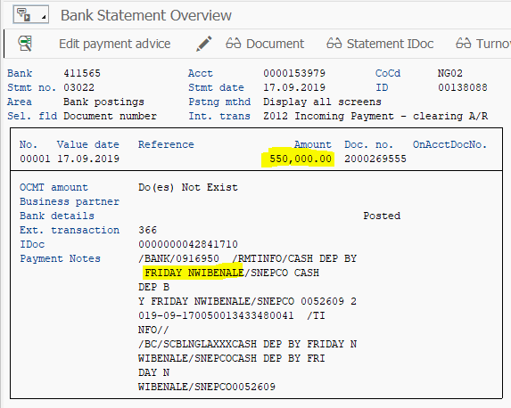

**DOC 280659719_DISPOSAL OF SNEPCo BATCH 2 WELLS MATERIALS AT ONNE (SNEPCo LOT)**

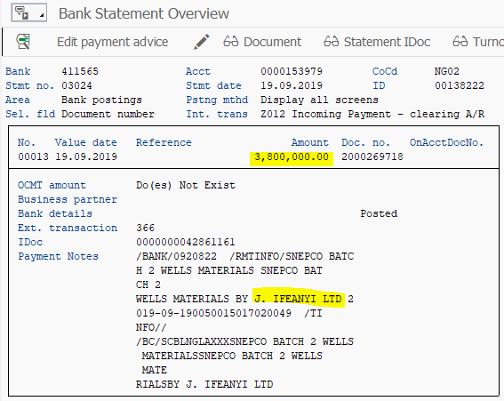

**DOC 280728124_DISPOSAL OF SNEPCo BATCH 2 WELLS MATERIALS AT ONNE (COMMUNITY LOT)**

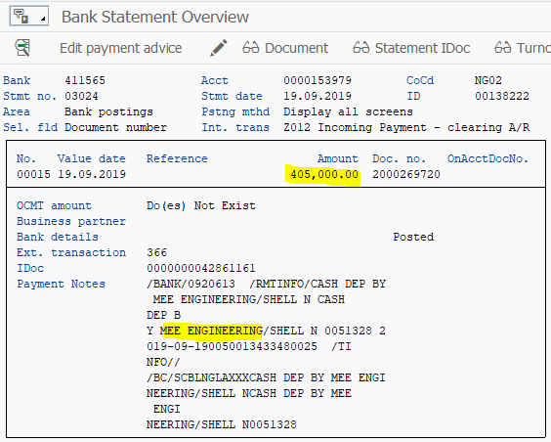

**DOC 280728192_DISPOSAL OF SNEPCo BATCH 2 WELLS MATERIALS AT ONNE (NAPIMS LOT)**

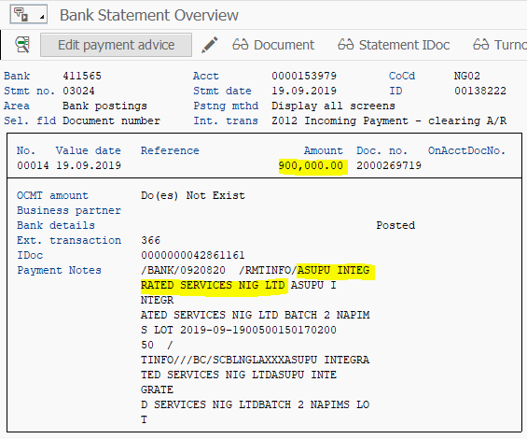

**DOC 280728192_DISPOSAL OF SNEPCo BATCH 2 WELLS MATERIALS AT ONNE (NAPIMS LOT)**

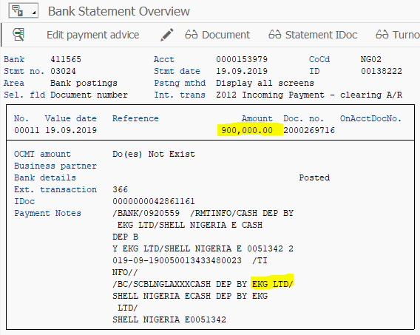

**DOC 280728192_DISPOSAL OF SNEPCo BATCH 2 WELLS MATERIALS AT ONNE (NAPIMS LOT**

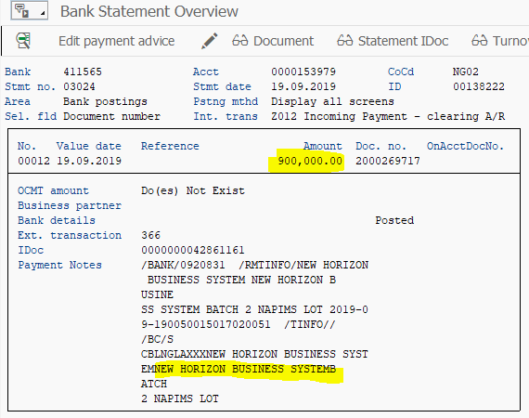

DOC 280728192_DISPOSAL OF SNEPCo BATCH 2 WELLS MATERIALS AT ONNE (NAPIMS LOT)

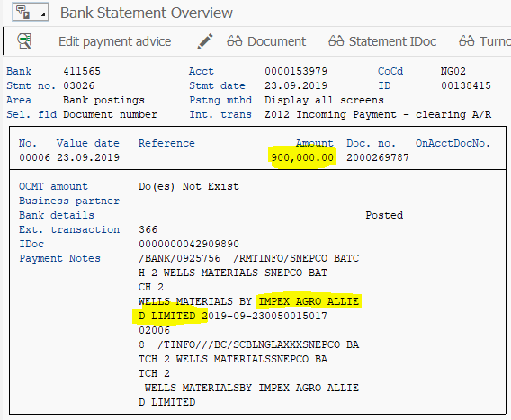

DOC 280633329_DISPOSAL OF BULKY WELLS MATERIALS AT ONNE (COMMUNITY LOT)

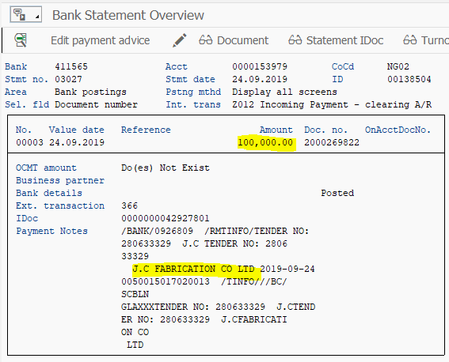

DOC286520102_DISPOSAL OF LOT 2 NG28 NON- STOCK SURPLUS MATERIALS AT ONNE_SNEPCO LOT

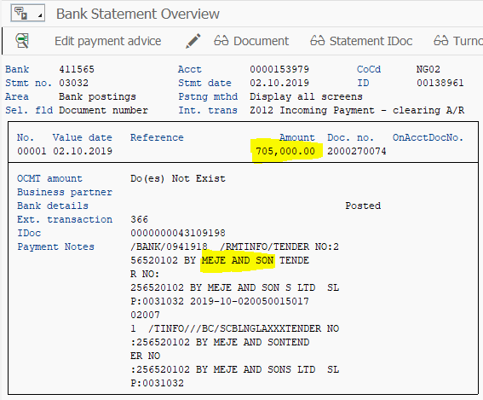

DOC287879323_DISPOSAL OF SUBSEA PLATFORM AND ITS ACCESSORIES AT SNEPCO ONNE GENERAL YARD SNEPCO LOT

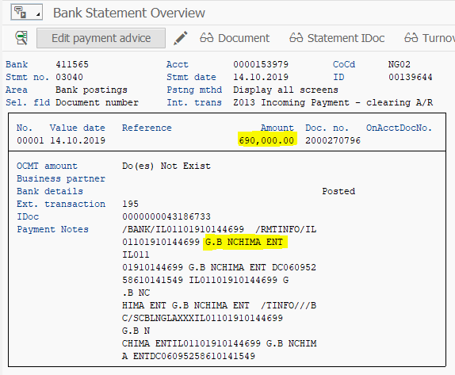

DOC 275547096_DISPOSAL OF BULKY MATERIALS AT ONNE NAPIMS LOT

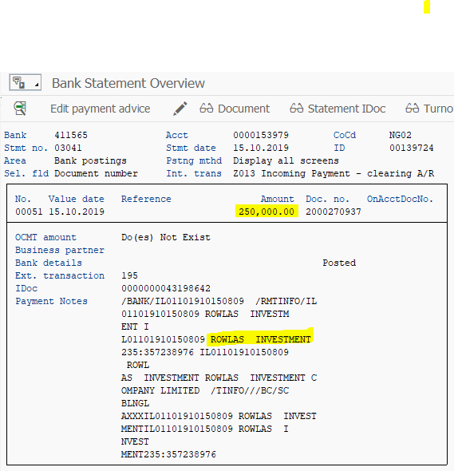

|  |  |
| --- | --- |
| NO    DOC 299060575_DISPOSAL OF WELLS BATCH 2- 7.5/8’’ 42.8’’ VAM ACE BOX X PIN, R3 AT ONNE (NAPIMS LOT | New Horozon Business System |

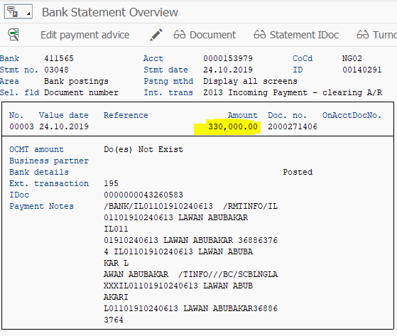

|  |  |
| --- | --- |
| NO    DOC 299060575_DISPOSAL OF WELLS BATCH 2- 7.5/8’’ 42.8’’ VAM ACE BOX X PIN, R3 AT ONNE (NAPIMS LOT | Asuru Integrated Services Nig Ltd |

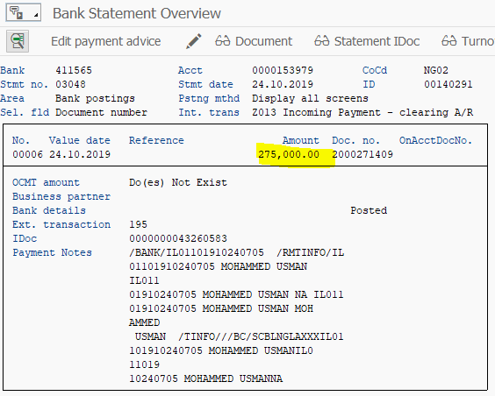

**NO DOC 299060575_DISPOSAL OF WELLS BATCH 2- 7.5/8’’ 42.8’’ VAM ACE BOX X PIN, R3 AT ONNE (NAPIMS LOT)**

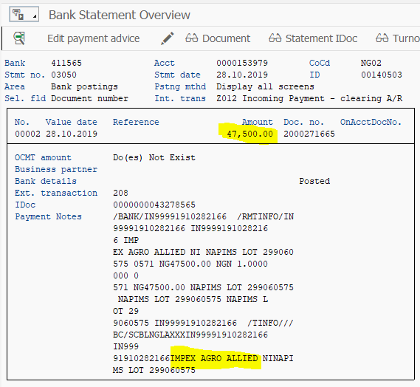

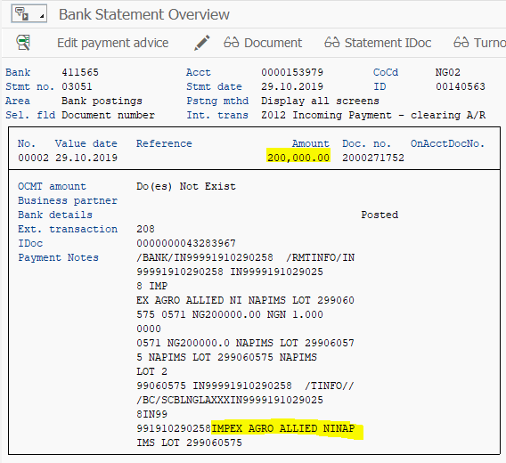

NO DOC 299060575_DISPOSAL OF WELLS BATCH 2- 7.5/8’’ 42.8’’ VAM ACE BOX X PIN, R3 AT ONNE (NAPIMS LOT

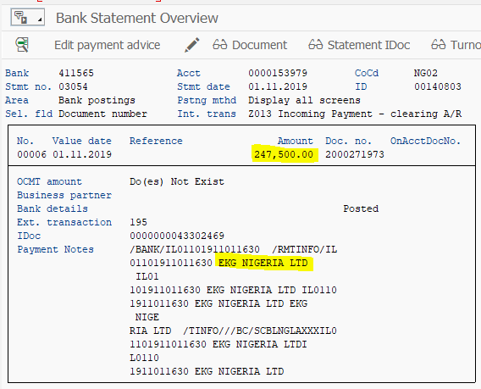

DOC 314382158_DISPOSAL OF BATCH 1 SNEPCO WELLS MATERIALS AT KIDNEY ISLAND COMMUNITY LOT

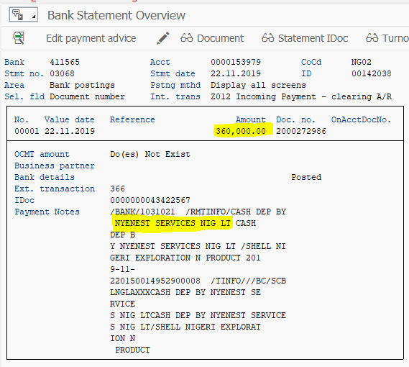

Doc 314096228 Disposal of Batch 1 SNEPCo wells Materials At Onne SNEPCo Lot

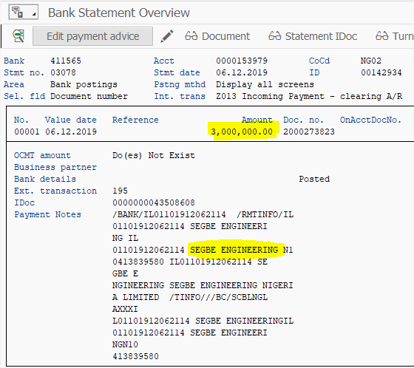

**DOC 314085900_DISPOSAL OF BATCH 1 SNEPCO WELLS MATERIALS AT ONNE (NAPIMS LOT)**

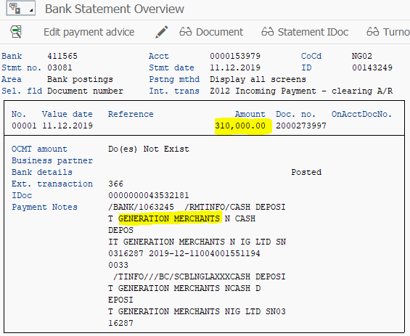

**NO DOC 314960864_DISPOSAL OF BATCH 1 SNEPCO WELLS MATERIALS AT ONNE (COMMUNITY LOT)**

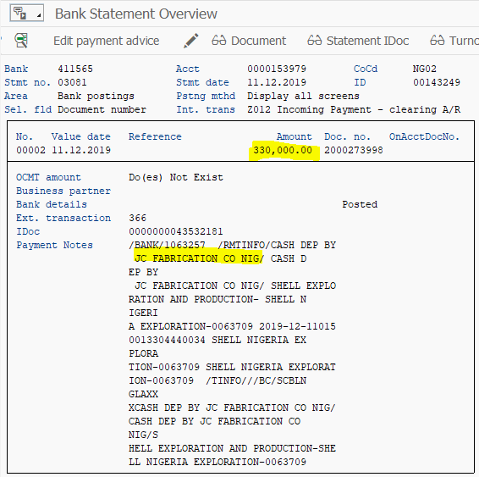

**DOC 317184595_DISPOSAL OF OBSOLETE PRODUCTION AND MAINTENANCE MATERIALS AT ONNE BATCHES 1 AND 2 COMMUNITY LOT**

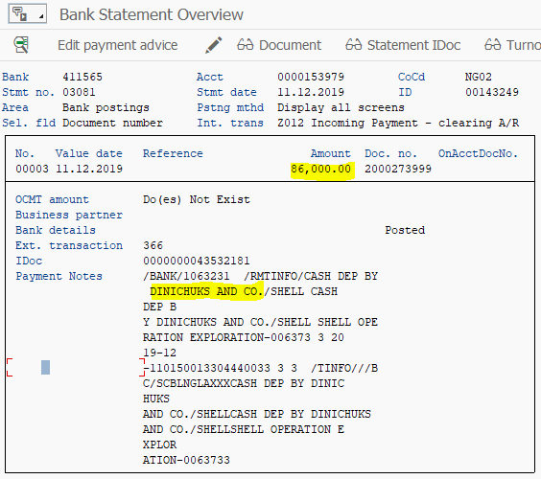

**DOC NO Doc332760284_DISPOSAL OF SUBSEA PLATFORM AT SNEPCO** YARD ONNE

